Kathleen De Clercq
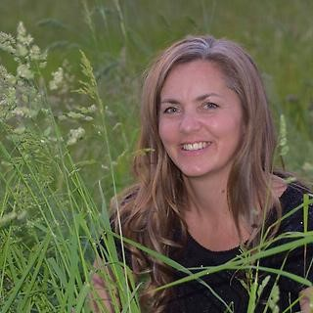
Kathleen De Clercq is Practical Lecturer ‘Green Management’ at the University of Applied Sciences PXL (Hasselt, Belgium) since 1996. She coaches students of the Green Management specialization in projects related to Therapeutic Greenery. Since 2014 Johan and Kathleen have been working together with the non-profit organization Terra-Therapeutica on interdisciplinary projects related to Horticultural Therapy and Therapeutic Greenery.

