Mirela Maganha
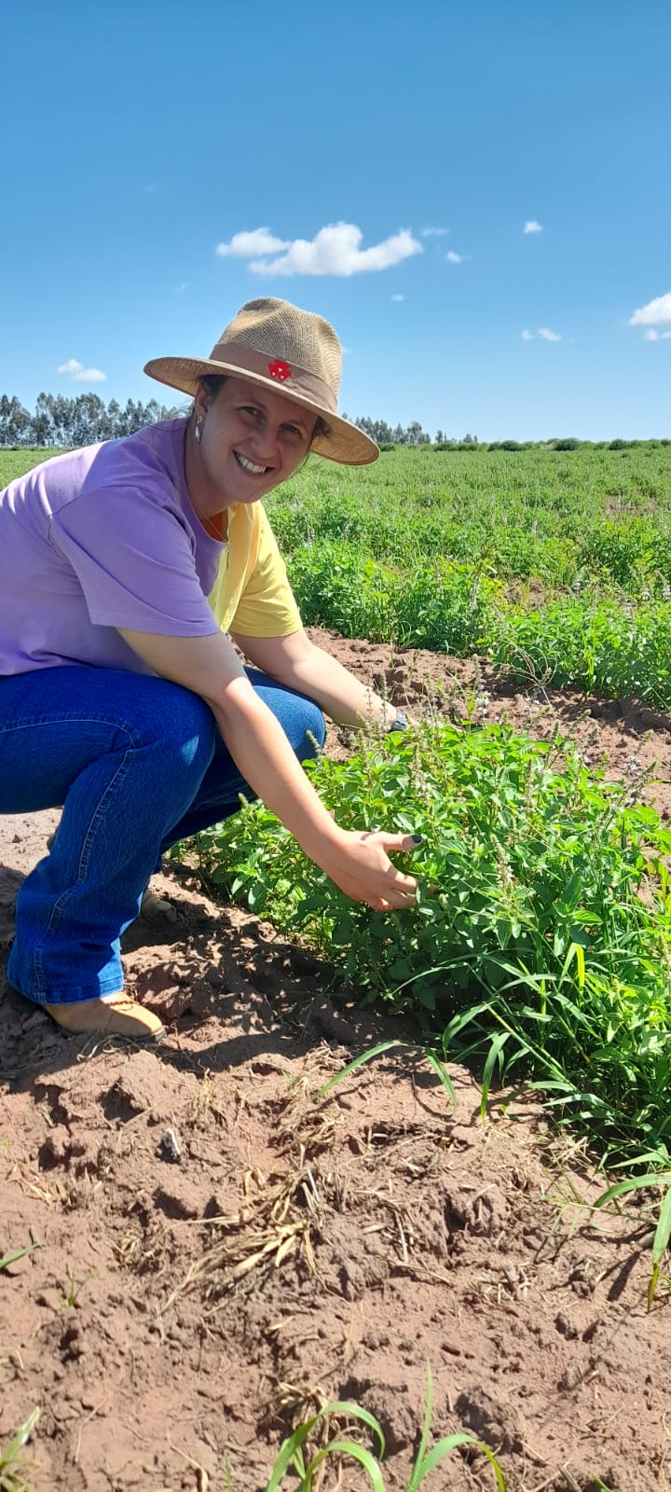
Based in Igaraçu do Tietê, in the state of São Paulo, Brazil. Mirela is studying for her Bachelor’s degree in Agronomy and will graduate later this year. Her first degree was in Management, followed by a postgrad in Project Specialisation (2015).

In 2021 as part of her agronomy studies, Mirela developed a therapeutic gardening project in a therapeutic community in Jaú, working with people affected by addictions who wanted to improve their wellbeing through activities with plants, exploring nature and learning how to grow vegetables and flowers.

