Aras Hewa Majeed

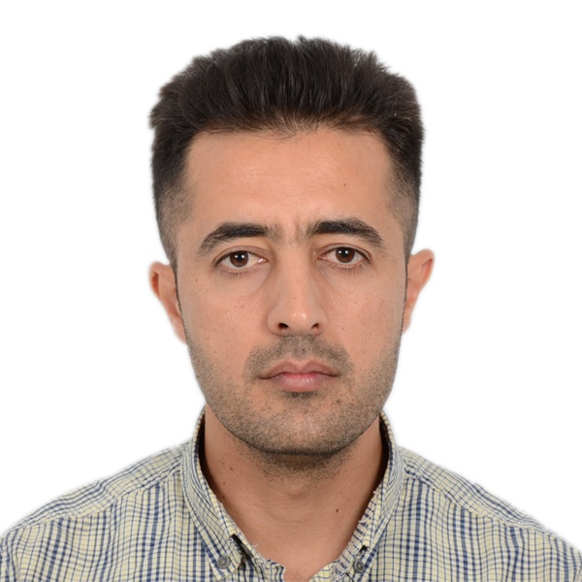
Aras Hewa Majeed
I am a psychologist with almost 10 years of experience in providing counselling and psychotherapy for people in need with different non-governmental organizations and using a wide spectrum of approaches and techniques.
I am also a horticultural therapist, hold a Master’s degree in psychotherapy and have been working with traumatized people.
I participated in the garden therapy training program in Kurdistan in the north of Iraq. Additionally I have over 20 certificates in different techniques and approaches such as CBT, EMDR, NET, Group therapy, Art therapy, and others, accredited in Kurdistan, Jordan, and Germany.
Now I work with the Jiyan Foundation as a Clinical Supervisor overseeing activities of team members engaged in clinical care.

